Qadiya Catalina de Arazuri
Kingdom of Calontir
Kingdom Arts and Sciences
Championship Entry
Spring 2014
Clothing of al-Andalus: The Durra’a and The Qamisa
The purpose of this project is to document and construct the Durra’a, an overlapping outer coat, and the Qamisa, the body shirt. We will talk about the country and period of origin, as well as the characteristics of style for that period. We will discuss the textiles and construction methods that were used to complete the project, and how they coincide with period practices. A presentation of period resources and scholarly references will be included.
Country, period of origin and characteristics in costuming of al-Andalus:
When the Arabs conquered Iberia in 711, they brought with them Islamic courtly fashion, with a Berber influence in the Military class. (Stillman & Stillman, 2003, p. 86) By the 10th century an Arab geographer, al-Muqaddasi, “observed that Maghribis dressed in the Egyptian fashion”. (Stillman & Stillman, 2003, p. 89)The 9th century brought with it the arrival of Abu l-Hasan ‘Ali Ibn Nafi, aka, Ziryab, a Persian musician, singer, poet and teacher. Ziryab is credited with bringing into al-Andalus the courtly fashion of the Umayyad Caliphate of Damascus. During the 9 -12th century the common courtly clothing for al-Andalus consisted of the:
- qamisa, the main body shirt, for both sexes
- durra’a or the jubba as the main robes, for both sexes
- Imana, turban for men only in al-Andalus (limited use)
- Ghifara, a wool cap of green or red was popular for all classes
- Sirwal, pants for both sexes
- Babuj, slippers
- Shirak, thong like sandal (Stillman & Stillman, 2003)
Most characteristics of Andalusian costume was not gender specific, there are very few items that deviate from each other. There are two distinct articles that differentiate between the sexes. The first and most easily explained is the qamisa, the differentiation is noticed in the length of the neck line. For men the neckline is either straight across, or goes to the sternum, for women the neck line slit will protrude all the way to her navel. It is easy to assume the reason for the lowered slit for a woman, due to the need to feed her children. The second differentiation is not only a differentiation between the sexes, but also differs in al-Andalus from the rest of the Islamic world, that is headwear. In all Islamic empires men wore the imana, in al-Andalus only men wore the imana and it was trimmed with a tiraz band across the tail. (Figure 5) In every other Islamic caliphate women were governed by Hadiths, laws, that prohibited them from being unveiled in public, in al-Andalus the Hadiths were not strictly enforced, and women were often seen bare headed in public. (Figure 2) They would wear a small filet tied around their head or an embroider cap. (figure 1)
Another characteristic of all Islamic clothing that deserves note is the tiraz band. Tiraz means to embroider or embellish. The letters of the Tiraz band would contrast the fabric to which they were applied to. A tiraz band is a line of inscription on the upper sleeves of a robe or imana sash. Examples can bee seen on figures in early miniature paintings, period example survive today. The tiraz band can be woven or embroidered into the fabric, appliquéd onto the fabric, or dyed into the fabric. (see figures 3 and 4)

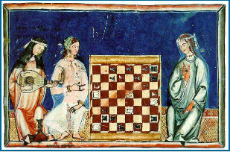Figure 1
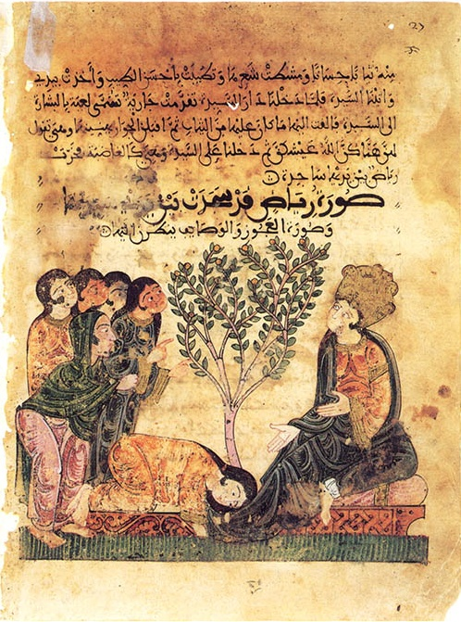
Figure 2
Figure 3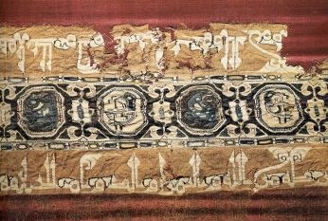
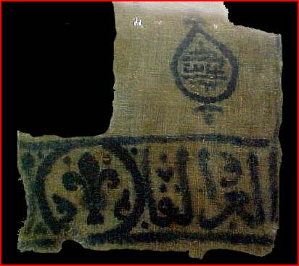
Figure 4
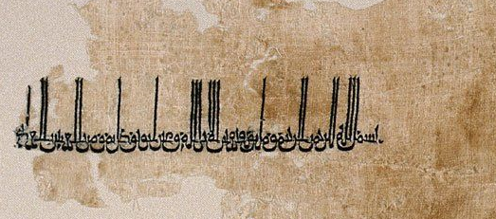
Figure 5
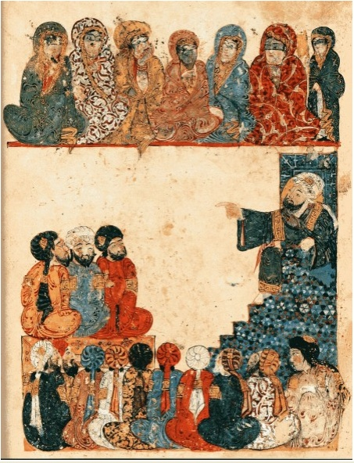
Figure 6

Textiles in al-Andalus
Linen, Silk, Cotton, Wool, and Metallic thread were in use in al-Andalus. There were at least 26 varieties of linen known to be cultivated in Medieval Egypt and Iran. Silk spread through the Islamic conquests to Iberia by the 10th century, Abd al Rahman II established a silk factory in Cordoba, Mucia, and Granada. (O'Callaghan, 1983, p. 156) Silk brocade was woven with gold and silver thread that had been wire drawn from ingots and twisted around the fabric core. (Baker, 1995) Cotton was grown in the region of Granada, Almeria and Seville. (O'Callaghan, 1983, p. 304) Wool was the fabric of simplicity and piety, Muhammad was said to only wear garments made of wool. Wool was woven from Goat, sheep and camel hair.
There are two garments that I have chosen for this project: the Andalusian coat, the durra’a and the Islamic body shirt, the qamisa.
The Durra’a
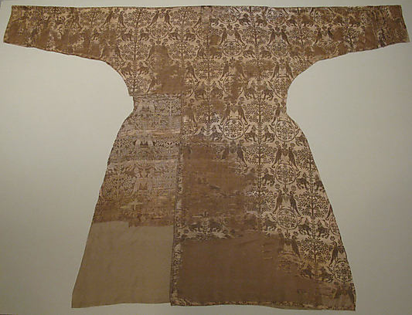Figure 7
The Andalusian coat or durra’a, 11th-12th century, medium Silk Metropolitan Museum of art
To design a pattern for this coat I used the zoom function on the Met Museum’s website. I was able to zoom in close enough to find seams and cuts in the fabric. I determined the seams by searching the image for breaks in the pattern. In the upper center portion of the coat the neck line is visible. The neck line is straight across the back and very small and close to the neck. (Figure 7) On the sleeves there is a visible seam that looks like an extension to make the sleeves longer, which is characteristic of Islamic clothing. The sleeves tend to be six inches or longer then the wrist when they are fitted. (Figure 8) The waist line of this coat shows the lines of a coat that is fitted at the waist.(Figure 9) No shoulder seams are visible, but that does not mean that they did not exist, in my pattern I choose to go without the shoulder seams and cut the pattern on the fold. The front of the extent piece is missing a section, originally I had thought this must be where a the fabric pieces had joined at a seam., after much scrutiny of the fabric, and citing no matching seam on the opposite side I am driven to assume this piece was cut or torn off due to wear that is evident on the rear panel of the same side of the garment.

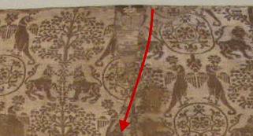
Figure 8
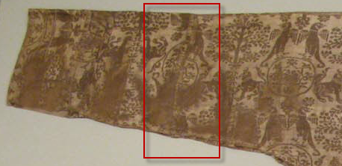
Figure 9
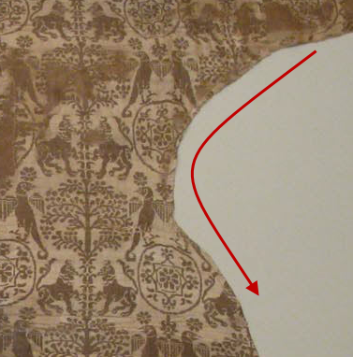
Figure 10

The pattern layout. This is how you will draw your pattern on your fabric.
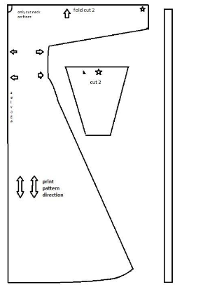
Figure 11
How to construct
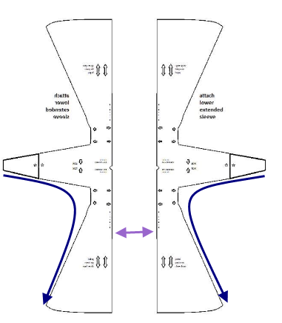Figure 12
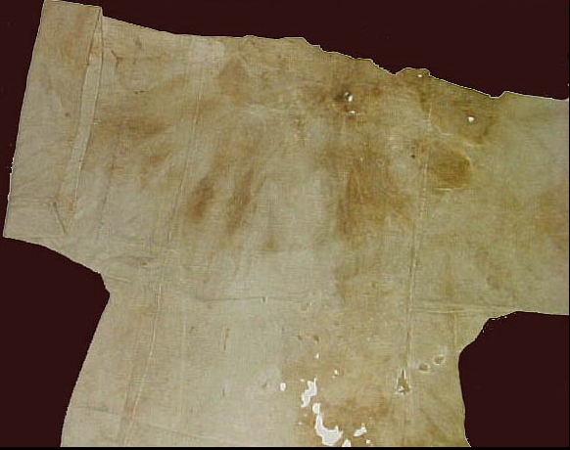
Figure 13
This undyed linen qamisa is the extent example I have based my pattern from. It is a 12th century Abbasid qamisa. This one has loose sleeves; I made my pattern with fitted sleeves for working.
This is how you will lay out your pattern on your fabric.
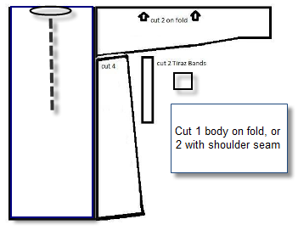
Figure 14
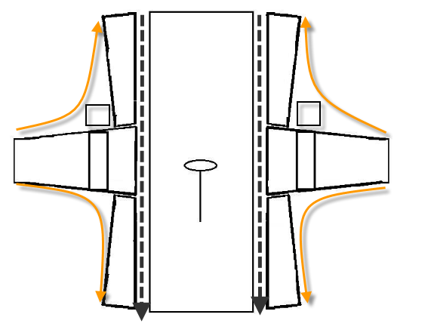
Figure 15

Bibliography
Baker, P. L. (1995). Islamic Textiles. London: British Museum Press.
O'Callaghan, J. F. (1983). A History of Muslim Spain. Cornell University Press.
Stillman, Y. K., & Stillman, N. A. (2003). Arab Dress: a short history: from the dawn of Islam to Modern times. Boston: Leidon.

