16th Century Dance from Khorasan
By Lady Vashti al-Asar
Shire of Westumbria, Calontir
Discovering what dance was like within the Persian Empire is a complicated process. The Empire encompassed a diverse group of ethnicities and religions. Major cultural influences included Hellenistic Greece, Arabic Islam, the Central Asian steppe, and the Indian sub-continent. Focusing on a narrow region and time span within the Persian Empire allows for a more focused study of dance. A plausible recreation of dance from the eastern edge of the Persian Empire can be reached by comparing present day Afghan folk dances with historical evidence.
Region and influences
Afghan folk dance and music are influenced by neighboring cultures, especially in the regions closest to the borders. Afghanistan is bordered by Iran to the southwest and Pakistan to the southeast. During the Persian Empire Pakistan was part of India and Afghanistan was part of the province of Khorasan in the Persian Empire. Historical evidence supports the theory of cultural exchange between the Persian Empire and India prior to the sixteenth century. In Objects of Translation, F.B.Flood explores how raiding, gift giving, and trade shifted cultural boundaries between Hindu and Muslim lands. Musical terms also evidence the influence Persia and India had on one another. For example, the Indian Sitar is related to the Persian Tar or Sehtar. The Indian singing styles of Ghazal, Tarana, and Qavali are based in Persian music, and the terms have Perisan origins. A 7/8th rhythm common in southern Afghanistan is referred as tal-e-Moghuli. The name is an Indian reference and a similar rhythm is found in north India. Persian dance is also referenced in Indian writings from the sixteenth and seventeenth centuries, the Nartananirnaya and Sangitadarpana. The texts describe Jakkadi (Jakkari) a dance introduced to Mughal courts by female dancers from Persia. In this dance style women swayed the edges of their garments and sang Persian songs accompanied by gestures and graceful movement of the limbs. In the Shahmaneh, Ferdowsi tells how the Persian ruler, Babur, asked his Indian father-in-law to send 12,000 Indian musicians to the Perisan court. While the number and specific incident may be exaggerated as legend, the general concept of musicians coming from India to the Persian courts is accurate. With trade and transport going between Persia and India, Afghanistan’s music and dance are influenced by cultures from both regions.
In addition to outside cultural influences, music and dance traditions also reflect the variety of ethnic groups within Afghanistan. Three major ethnic groups are Pashtuns in the southern half of the country, Tajiks who may be the original inhabitants of the region, and the Uzbeks and Turkomen of Central Asian descent in the north. It is common for each ethnic group to have its own variation of a dance. Folk dances are also presented on stage and in competition by ethnic organizations and in this way they function as cultural identifiers of the peoples of Afghanistan. There are many types of folk dances including combat dances using sticks or swords, solo improvisational styles, line or circle dances, and religious or ceremonial dances. For this project I focus on solo improvisational dances performed by women in Afghanistan. After examining common movements and costumes, I will present historical evidence tracing similar images back to the sixteenth century.

Modern folk dances
The Nasta, Ishala, Ghamzegi, and Logari are improvisational styles performed as solos by women in Afghanistan. Variations of the Nasta and Ishala are found throughout the country. Both dances are performed at happy occasions and intended for the amusement of others. In some cases, the dance begins with the telling a comic story; the performer rises to dance as she continues the tale. The Ghamzegi originated in Herat. The people of Herat share many cultural aspects with those living across the border in Khorasan, Iran. The Ghamzegi, especially focuses on the dancers’ ability to express naz, the Persia term for coyness which is considered an important aspect of the female psyche in the East. The Logari is characterized by sudden stops in the music during which dancer pauses. Despite different origins, the repertoire of movements, general costuming, and music are similar among these styles.
Movements are characterized by graceful hand gestures which may frame the face, tumble over one another, or flow back and forth. Many of the movements imitate daily tasks, such as putting on makeup, arranging one’s hair, sewing, sowing, and picking fruit or flowers. Common body positions include standing, kneeling, or swaying. Other common moves include neck slides, expressive facial movements especially of the eyes and eyebrows, and a ball/flat foot pattern with one foot nearly flat and the other foot half raised. Fast spins are also a frequent element. Spinning may be combined with an arm and hand pattern or the ball/flat foot pattern. The use of veils, small scarves, or skirts held by the edges and moved in time with the music are also seen in these dances. The veil is worn as part of the woman’s headgear and not a separate piece as seen in modern belly dance. Small hand scarves may be used to add color and movement to hand gestures. While some movements may include brief narrative elements or represent daily tasks the movements are not codified as Indian dances, such as Khatak. The dancers choose from a range of movements which are familiar and acceptable within their culture. However, the styles are generally considered to be improvisational. Dancers are judged, not only on their ability to execute movements in graceful interpretation of the music, but also their ability express naz.
Music
Afghan folk music includes a variety instruments similar to those found in paintings of dance scenes from the sixteenth to the nineteenth centuries. Commonly seen stringed instruments include the rebab (robab), tanbur, and dutar; several types of drums such as the dohl, tabla, and zerbaghali, and flutes such as the tula. There is evidence that music was influenced by story-telling traditions, particularly epic tales and poems which are common among the Pashtuns, Tajiks,and Uzbecks. The narrative aspect of some popular folk dance movements supports the idea that dance developed as an interpretation of the story being told by the music.
Costumes
Modern folk dance costumes are usually vibrantly colored dresses with sleeves reaching to the elbows or the wrists. A long rectangular veil is attached at the head and hangs nearly to the floor. The bodice of the dress is fitted and may be decorated with embroidery or shiny discs resembling coins. The skirts are very full and are seen in various lengths reaching the knee, calf, or ankle. The pants are ankle length and do not balloon as do stereotypical “harem pants” (Figures 1 and 2). Costumes from north India bear striking resemblance to the Afghan costumes (Figures 3 & 4). Similarities between modern costumes and those from the 14th through 16th centuries can be seen in the images shown below (Figures 1-6).
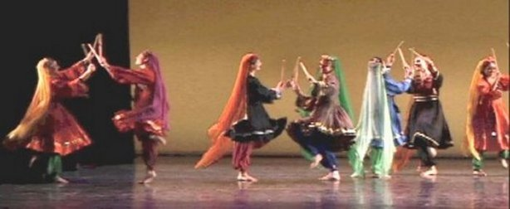
Figure 1. Folk dancers performing Chopbazi (stick dance) pictured in “Afghan Dance” Eastern Arts http://www.easternartists.com.

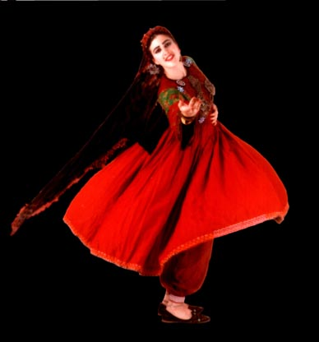
Figure 2. Professional folk dance artist Helen Eriksen performing an Afghan dance.
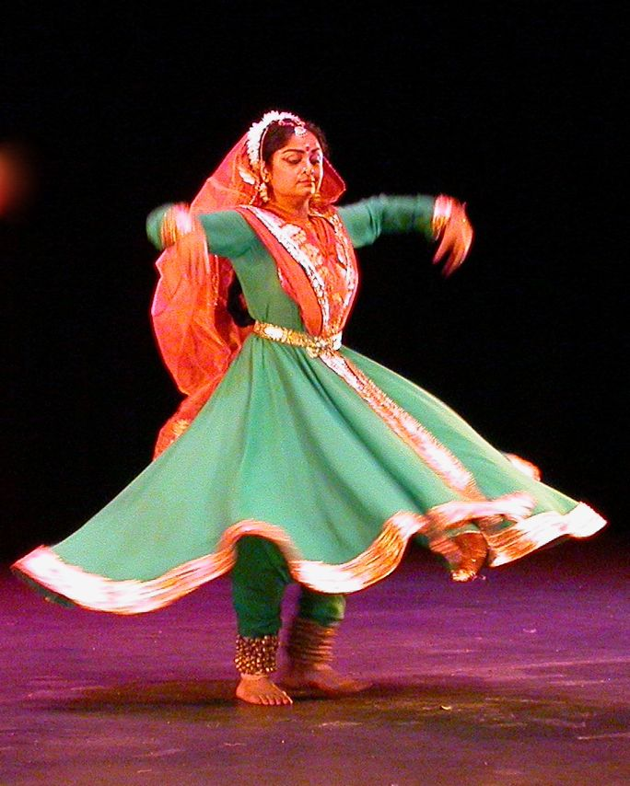
Figure 3. Kathak dancer (Indian) http://www.konarkdanceschool.org/dancestyles.html - note the similarity in costume to the Afghan dancers.

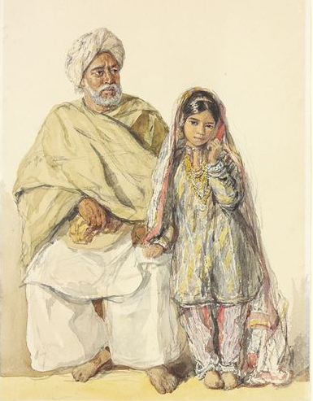
Figure 4. The Victoria and Albert Museum. Painting from Indian by William Carpenter 1855.

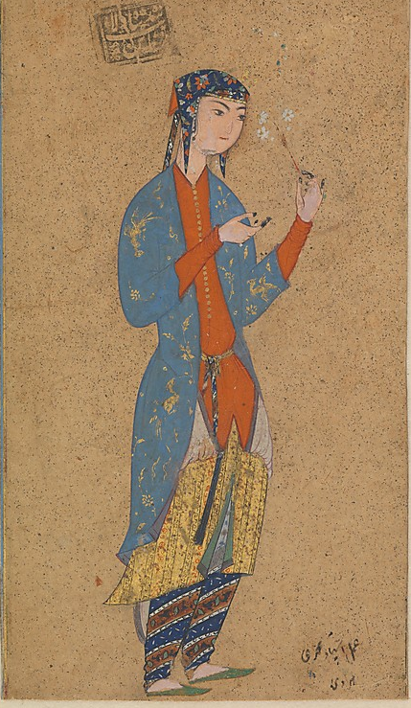
Figure 5. The Metropolitan Museum of Art. “Portrait of a Woman Holding a Flower” 1565-75 from Heart, Afghanistan.
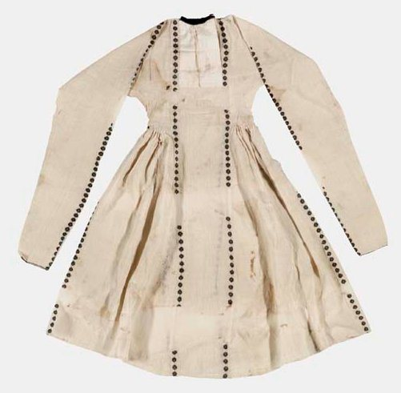
Figure 6. Christie’s. Fourteenth century chemise from Afghanistan. Plain weave cotton embroidered with rosettes in black cotton thread.
Persian Dance from 17th – 19th centuries
Considering the exchanges between Persia, India, and Afghanistan artifacts from Persia and India will be used to help illustrate what Afghan dance may have looked like in the sixteenth century. Making a comparison across a vast expanse of time involves a certain amount of conjecture and inference. The guesswork can be reduced by considering images from the recent past as a transition between modern dance and that of the sixteenth century. The costume and body position of figures 7-10 show that dance has not changed drastically from the 17th century to the 19th century and on to the present. The figures are understood by modern dancers to be women dancing.
While the details such as head pieces and jewelry may differ, there are two common costumes in examples from the 17th-19th centuries. Costume style Number 1: a fitted bodice or top and a full skirt, a scarf tied at the waist, and a head piece (Figures 7-9). Costume style Number 2: is an ankle length dress or outer robe with narrow sleeves, a thin scarf tied at the waist, and a head piece (Figure 10-.17).
The most common body position is feet flat with toes pointed forward. The dancer has her arms extended up on one side and down on the other with elbows slightly bent. Several images show the dancer with her head turned to one side and slightly inclined. The images with fuller skirts show more variation in leg position, including one leg extended or one leg lifted with a bent knee. While the exact nature of the movement cannot be gained through static images, the costumes and body positions are familiar to modern dancers.
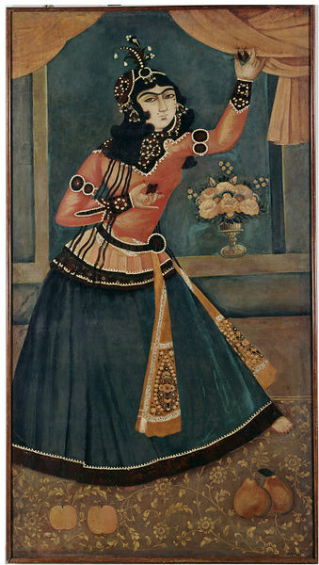
Figure 7. Victoria and Albert Museum. Museum No. 715-1876. Nineteenth century oil painting shows a lady dancing and playing castanets. The portrait was initially thought to be a member of Fath Ali Shah’s palace in Terhan, Iran. The portrait may be from the palace, but it is likely that the dancer was from the artist’s imagination. While the image may be from the artist’s imagination it would have been recognizable to 19th century audiences as a woman dancing. Note that one leg is weighted and the other extended with the toe pointed.
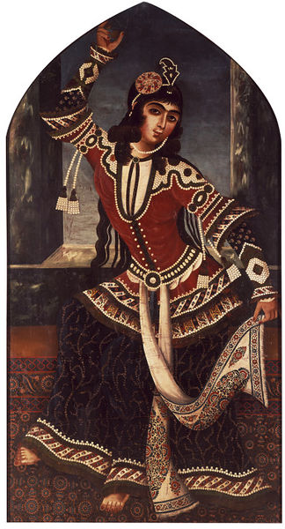
Figure 8. Victoria and Albert Museum. Museum No. P.21-1933. Nineteenth century oil painting shows a lady dancing. Also from the palace of Fath Ali Shah in Tehran, Iran. She holds one arm extended above her head and the other arm in front of her bent at the elbow. Note: The dancer is holding the edge of the sash tied about her waist. Her weight appears to be on one leg with the other leg raised off the floor with a bent knee.
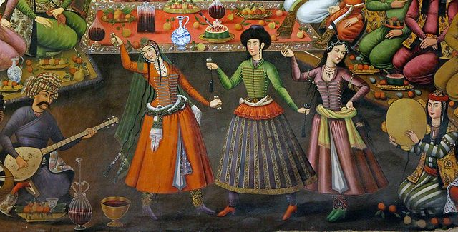
Figure 9. http://www.flickr.com/photos/21259491@N02/6864623815/ Mural of three women dancing from the Chehel Sotoun (Forty Columns); a garden palace built in 17th century Isfahan, Iran. Note that the girls on the right and left have their heads turned and inclined. While all three use the common arm pattern, the woman on the right has one hand on hip which is a less common position.
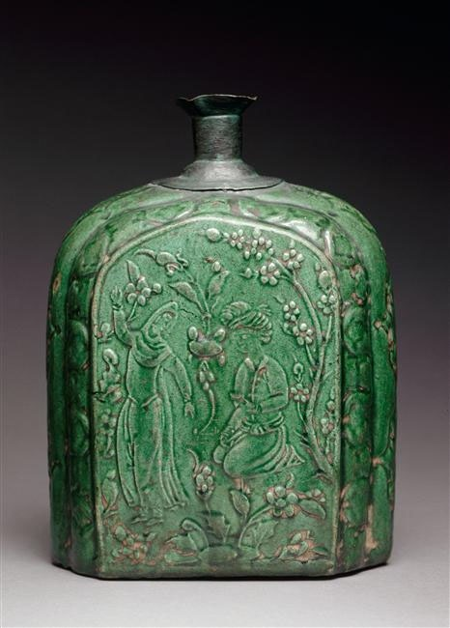
Figure 10. From the Louvre. Obtained from the Middle Eastern Dance Guild at http://awalimofstormhold.wordpress.com/tag/history-of-the-dance/
A 17th century flask from Isfahan shows a dance scene in a garden. The flask, made of clay paste with molded decoration, has less detail than paintings. However, the body position of the dancer is similar to that of the later paintings and shows the second costume style.
Period literary references to dance
In the 7th century Arabic Muslims invaded Persia. Arabic conquerors often remained ethnic and religious minorities in conquered areas and eventually mixed with the indigenous populations. Turkic administrators and military leaders began to displace Arabic rulers in the eastern part of the Persian Empire as early as the 10th century. The Empire was ruled by Turkic dynasties until the Mongols invaded from the east in the 14th century. While Arabic rule over the Persian Empire was relatively short, the cultural influences were long lasting. Primary among these influences was the religion of Islam. While Islam was the dominant religion in much of the Empire, the rulers did not always enforce strict laws against dance and imagery. Persian and Turkic peoples within the Empire had strong traditions of figure painting. Scenes of court life and entertainment such as drinking, dancing, and making music were common in their artwork. In addition to the many paintings and ceramics are literary sources which should be considered.
Muruj al-dhahab (Golden Meadows) was written by al-Mas’udi in the 10th century. In the nineteenth century fragments of this work were translated from French to English. In an excerpt al-Mas’udi describes eight modes of dancing, as well as the qualities of temperament, physique, and practiced arts that are desired in dancers. Of temperament he said a dancer should have “vivacity of spirit, sense of rhythm, and cheerfulness in the performance of the art.” Regarding the ideal physique al-Mas’udi prized “a long neck, side locks, expressiveness, a natural sway, a slim and graceful waist, vivaciousness, a well-proportioned figure, accomplishment in the art of swirling the hem of the robe, control of breathing and rests, patience in endurance, agile feet and flexible toes to perform the harmonious movements of the different dances, from the camel dance to the ball dance, flexible limbs, speed in whirling, and soft curves.” And of arts gained by practice al-Mas’udi stated “ the ability to perform a variety of dances, to swing the body with grace while the feet remain firm about their turning point, and while equal balance is maintained between right and left. Dance steps can take two forms: one on the beat and the other off the beat. The dancer must keep to the movement in which the dancer excels and let it rise when on the beat, and drop when not. The best is that which comes naturally and harmonizes with love and beauty.”
Jalāl al-Dīn Muhammad Balkhī, also known as Jalāl al-Dīn Muhammad Rūmī was a well-known poet-philosopher of the thirteenth century. He is known in the West today simply as Rumi. Dance and music imagery frequently appear in his poetry, such as “…the wind moves to dance/any branch that isn’t dead. In the context of his own society and time, Rumi’s poetry used these descriptions as a way to bring one closer to God. However, his use of music and dance metaphors support the idea that dance and music were familiar entertainments for the upper class who would have been literate and had spare time to read poetry and consider philosophy and religion. According to Coleman Barks, Rumi’s understanding and use of language was often explained in musical terms. For example, Rumi often asks “Who is making this music?” Or rather than including his own name in one the last lines of poetry, as was common among practice, Rumi would give the poem to “the invisible flute player: let that musician finish this poem.”
Dance, when you’re broken open
Dance, if you’ve torn the bandage off.
Dance in the middle of the fighting.
Dance in your blood.
Dance, when you’re perfectly free.
Persian dance from the 15th and 16th centuries
While costumes and venues have changed, the historical evidence from the 16th century makes it apparent that the movements and postures of dance have not changed drastically over time. The majority of figures 11-17 show dancers in the second costume style.
Figure 11 -A 16th century painting from the FitzWilliam Collection. Painted in 1565 in Bukhara. Note: The unusual arm position and two small hand scarves.
Figure 12 – Detail from a 16th century Persian miniature, “Siyavush and Fanagis Wedded” from the Metropolitan Museum of Art, Folio 185. Note: Dancer is holding 2 small hand scarves. Her head is turned to one side and inclined.
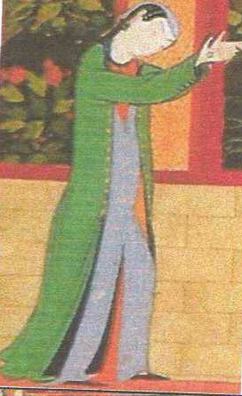
Figure 13 – Detail of a lady dancing from a courtyard scene, both hands raised in front of her with head inclined. Picture is from Lentz pg 275.
Figure 14 - Dancer with a one longer scarf at a wedding. Note the crossed leg and bent knee position. Page 55, Timur and the Princley Vision.
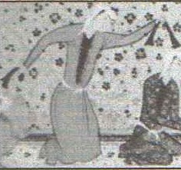
Figure 15 - Dancer in a kneeling position using 2 small hand scarves. I included this image because it is the only one I have seen of a dancer kneeling. From “16th Century Persian Dance” by Milesent Vibert (Grace Vibbert) Middle Kingdom A&S Competition 2006. She cites it as from Rylands Collection manuscript pictured in Medieval Persian Court Poetry by Julie Scott Meisami. The edition of the book I was able to find did not have images.
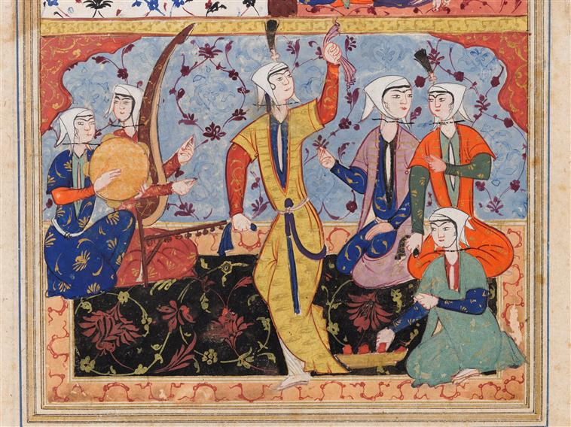
Figure 16 –http://awalimofstormhold.wordpress.com/tag/history-of-the-dance/ Detail of 16th century Persian manuscript, Rostram’s Wedding. Note: Foot position – may be a cross step with back foot off the ground
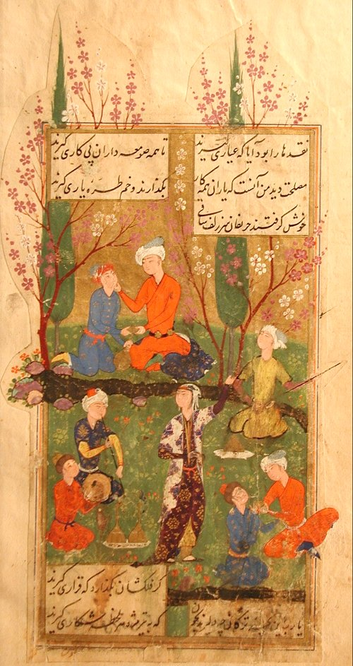
Figure 17 - http://www.pakzad-orientteppiche.de/museum/kunsthandwerk/index.shtml 16th century Persian miniature painting by Hafiz. Note one arm position with one arm extended and the other bent at the elbow framing in front of the dancer.
Comparing images offers a similarity of body positioning and costume which imply a continuity in dance overtime. However, such positions and costumes are seen in images across many locations and time periods (Figure 18 & 19). It is, however, an understanding of cultural interactions among the peoples within and near the Persian Empire that enable us to infer the nature of the movements depicted. It is a combination of the images, writings, and cultural influences which helps us to understand the aspects of modern Afghan folk dance that are truly modern and which are long lasting historic traditions.
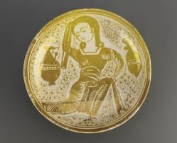
Figure 18 – Egyptian luster ware bowl with dancer, early 11th century.
http://www.qantara-med.org/qantara4/public/show_document.php?do_id=1225
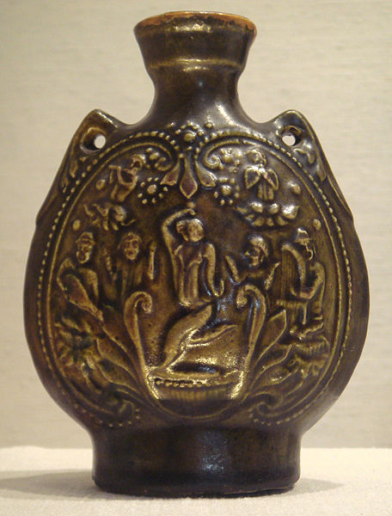
Figure 19 – The Metropolitan Museum of Art. Northern Qi Jar with dancers and musicians dated 550-577.
My garb
I modeled my garments from paintings, ceramics and extant garments from the 14th through the 16th centuries in Iran and Afghanistan. My garments include pants with slightly tapered legs and drawstring waist, a wool blend checkered dress with high contrasting neck line, and an outer robe/coat tied with a sash with pearl details couched at the cuffs. My skirts are longer and less full than the modern costumes. The dress was my first attempts at construction based on Figure 6 with gathered side gores. The checkered pattern was referenced in Arab Dress, Chapter 2: “The Evolution of the Islamic Vestimentary System Under the Caliphates.” The outfit for this project was put together from my existing wardrobe and approximates the general look, but is not entirely appropriate. I chose a short kerchief style head coverings of muslin and silk with a strand of pearls under the chin and a silk braid case. The images of sixteenth century dancers showed this style more frequently than the long veil common in modern folk dance. This was my first attempt at creating this style of head covering. I created the outward look, but did not use construction methods. This style of head covering was likely pinned to a small felted wool cap. In the future, I hope to improve the construction process of the head covering. Linen, silk, and cotton would have been more appropriate fabrics than synthetic and wool. Wool was largely worn by the lower class according to Arab Dress and the extant garments I have seen thus far in my research. A more accurate outfit would include at least one more layer, a linen or cotton “under-dress” or “body shirt” as a base layer. Also, for a 16th century costume, the neckline of the dress would most likely be deeply split and fastened at the top creating a narrow gap at the bust. Additionally, the 16th century paintings show that outer robbers with short sleeves and a straight front opening were more than the long sleeved cross front coat I am wearing. My initial focus for persona was 10th through 14th century eastern Persian Empire. The garments for this time period and region do not commonly feature the deeply split neckline and short sleeved, straight front outer robe.
Comparison with period images
Based on the commonality of certain poses in historical images of dance it may seem that a recreation is limited to movements that resemble the poses. However, dance is not a series of poses, but rather the means of transitioning from one pose to another. If the historical images of dancers were painted from models the images are limited to the poses which may be held stationary for extended periods of time. Figure 20-25 show me in costume in dance related poses that are relatively easy to hold for several minutes at a time. These poses have been modeled after the historic images presented in this paper. While any recreation of 16th century dance should begin with an examination of the historic evidence the recreation should not be limited only to what is seen in static images.
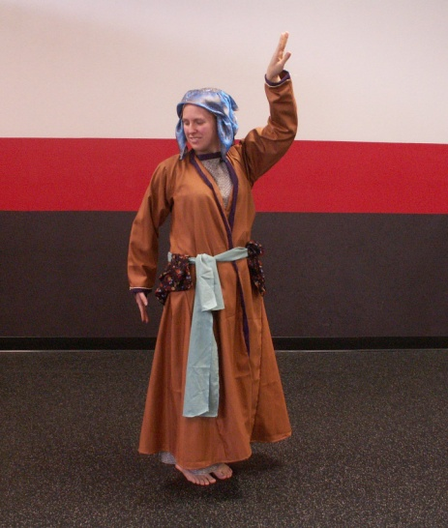
Figure 20 Figure 16 Figure 10

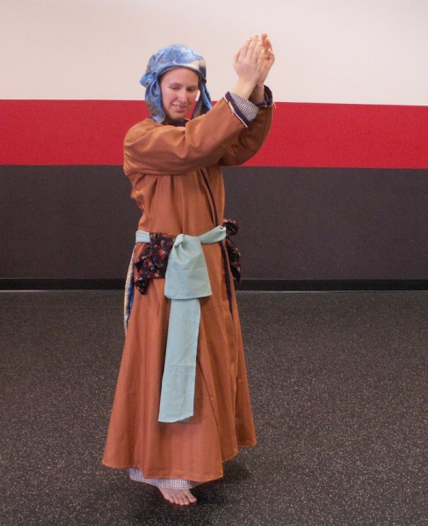
Figure 21 Figure 13
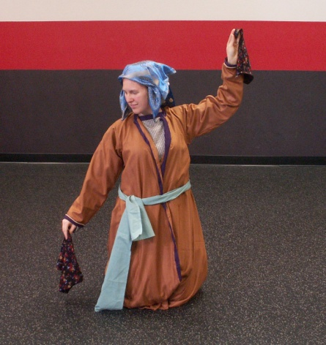
Figure 22 Figure 15
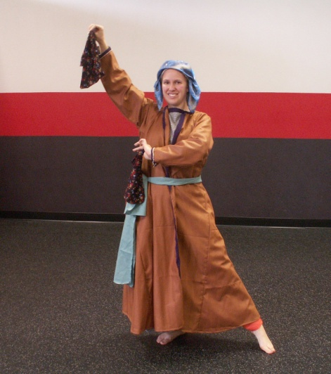
Figure 23 Figure 17
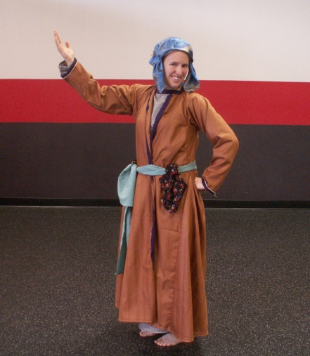
Figure 24 Figure 9
Movements, music, and video sources
In preparing this dance project I examined videos of modern folk dances from Afghanistan and compared the movements, costumes, and music to what is seen in the historical evidence. My most abundant source for such material was YouTube.com. Primarily I reviewed the dances performed by Eastern Arts, a non-profit dance and music organization focused on the traditional dances of Persia/Iran, Afghanistan, and the Middle East. And Miriam Peretz, a professional dancer and choreographer who specializes in dances of the Silk Road and Middle East. Unfortunately, I did not find examples identified as the nasta or ishala. I found several examples of the Ghamzegi and other dances identified as Herati. Using these videos as a starting point, I selected music appropriate for a Herati styled dance. The music is found on a cd collection called Afghanistan Untouched which was recorded in the 1960s as part of a project to preserve traditional music of the various ethnic groups in Afghanistan. The song is called “Ghori” after the mountainous region of Ghor in eastern Herat and is similar to music heard in Khorasan, Iran. The music is played on a dutar, a long necked lute with two strings. In keeping with the concept of improvisation, my performance is only loosely choreographed. I am familiar with the music and have practiced a variety of movements and attitudes/expressions in the hopes of performing the movements with grace and musicality. However, there is not a set schedule or order to the movements. There are 6 basic types of movements which make up this performance:
- the ball/flat foot pattern in which one foot is flat and the other foot is on the ball. With small nearly shuffling footsteps and knees bent this travelling movement allows for a gliding appearance.

- The majority of the dance is performed with the hands and arms.
*Several hands patterns emphasized hiding and revealing the face. Revealing the face was often combined with a head slide and coy smile.
*The most common hand movement was simply turning the hand front and back with a gentle articulation through the fingers. Fingers are kept together during this movement. This may be done with or without small hand scarves
3) Grasping and gently swinging the edges of the skirt or long scarves.
4) Shoulder movements include a bounce which emphasizes the down movement of the shoulders and a gentle front and back movements of the shoulder with arms by the sides or below shoulder height.
5) Some of the everyday activities seen in the dance movements were sewing, sowing, washing clothes, putting cosmetics, and arranging one’s hair.
6) Spinning – usually with the ball/flat foot pattern and usually in combination with a hand or arm pattern.
Here are some of the modern folk dances which influenced my project:
Afghan Traditional Dance Suite by Eastern Arts (several solos and a couple group numbers)
http://www.youtube.com/watch?v=dOyy-C1OXY4&list=PL5978297ADDB15263
Afghan Dance – Miriam
http://www.youtube.com/watch?v=ObSl6s8MDsA
Dance from Afghanistan by Helene Eriksen (solo)
http://www.youtube.com/watch?v=j3pakDFesns
Ghamzegi (Herati) Dance by Apsara
http://www.youtube.com/watch?v=FJ2c9-bvpVA
Ghamzegi (Herati) Dance by Apsara
http://www.youtube.com/watch?v=wFvfK8MQRwY
Afghan Herati Traditional Folkdance
http://www.youtube.com/watch?v=T5onlY2Qwjc
Afghan Logari and Herati Dance Solos by Katherine St. John
http://www.youtube.com/watch?v=i3kvGKQq-Mw
Persian Dance (solo)
http://www.youtube.com/watch?v=1vi5fa2ZLwo
Mash Mash Allah – Persian Classical (Qajar) Dance by Apsara http://www.youtube.com/watch?v=UtpN1H-bsTk
Lovely Dance on Pastho Music (group dance with small hand scarves)
http://www.youtube.com/watch?v=DGNjOZN13iY
Afghan Folkdance at Kabul University (group dance with small hand scarves)
http://www.youtube.com/watch?v=mxcd2biONsM
Meghranjani Sudha Nritya (Kathak Dance) (see hand/arm movements and head/facial accents starting at 3 minutes)
http://www.youtube.com/watch?v=1ZmCmQjoehw
Tarana – Kathak (hand and arm movements – stopping with the accents in the music)
http://www.youtube.com/watch?v=m8Cgr1dgxmA
Bibliography
Adly, Hanaa M., “A Study on Islamic Human Figure Representation in Light of a Dancing Scene” web.mit.edu/akpia/www/articleadly.pdf‎, pg 1-10.
“Afghan Dance” Eastern Arts http://www.easternartists.com
Afghanistan Untouched. Traditional Crossroads: New York, 2003 (audio cd)
Al-Faruqi, Dr. Losi Ibsen, “Dances of the Muslim Peoples” A Comprehensive Curriculum in Dane for Secondary Schools by Dr. Nadia Chilkovsky Nahumck.
Al-Mas’udi. Muruj adh-dhahab wa ma'adin al-jawahir (Meadows of Gold and Mines of Gems). http://awalimofstormhold.wordpress.com/
“Arusi,” Encyclopedia Iranica. Http://www.iranicaonline.org/articles/arusi
Barks, Coleman (translator). The Essential Rumi. Harper Collins: 2004.
Diba, Layla S. “Invested With Life: Wall Painting and Imagery Before the Qajars” Iranian Studies, Vol. 34, No. 1-4, 2001, pg 5-16.
Flood, F.B., Objects of Translation: Material Culture and Medeival “Hindu-Muslim” Encounter, pg 1-15. Princeton University Press: New Jersey, 2009.
Gabbay, Alyssa. “Love Gone Wrong, Then Right Again.” http://libres.uncg.edu/ir/uncg/f/A_Gabbay_Love_2009.pdf
“Jakkadi” Encyclopedia Iranica http://www.iranicaonline.org/articles/jakkadi
Lentz, Thomas W. and Glenn D. Lowery Timur and the Princley Vision: Persian Art and Culture in the
Fifteenth Century. Smithsonian Institution Press, 2nd ed. Washington D.C., 1989
Mesiami, Julie Scott (translator). Nizami Ganjavi (author). Haft Paykar: A Medieval Persian Romance. Oxford: 1995.
Nasehpoor, Nasrollah, “Impact of Persian Music on Other Cultures and Vice Versa” Art & Social
September, 2002, pg 4-6 (Vol. 37) http://www.parstimes.com/music/persianmusic_impact.html
Stillman, Norma A. Arab Dress: A Short History From the Dawn of Islam to Modern Times Vol. 2, Brill Academic Publisher: Boston. 2003, pg 30.
Vibbert, Grace “16th Century Persian Dance,” Middle Kingdom A&S Competition, May 2006.

Meri, Josef, editor. Medeival Islamic Civilization Encyclopedia (Inedx A-K). Vol 1. Routledge: New York. January 2006.
“Afghan Dance” Eastern Arts http://www.easternartists.com
Battuta, Ibn, Travels in Asia and Africa 1325-1354. Routledge, 2004. Pg 175-176.
Flood, F.B., Objects of Translation: Material Culture and Medeival “Hindu-Muslim” Encounter, Princeton University Press: New Jersey, 2009, pg 1-15.
Nasehpoor, Nasrollah, “Impact of Persian Music on Other Cultures and Vice Versa” Art & Social Vol. 37.
“Afghan Dance” Eastern Arts http://www.easternartists.com
“Jakkadi” Encyclopedia Iranica http://www.iranicaonline.org/articles/jakkadi
Nasehpoor, Nasrollah, “Impact of Persian Music on Other Cultures and Vice Versa” Art & Social September, 2002, pg 4-6 (Vol. 37) http://www.parstimes.com/music/persianmusic_impact.html
Ibid
al-Faruqi, Dr. Losi Ibsen, “Dances of the Muslim Peoples” A Comprehensive Curriculum in Dane for Secondary Schools by Dr. Nadia Chilkovsky Nahumck.
“Afghan Dance” Eastern Arts http://www.easternartists.com
Ibid
Ibid
Ibid
Afghanistan Untouched. Traditional Crossroads: New York, 2003 (audio cd)
Stillman, Norma A. Arab Dress: A Short History From the Dawn of Islam to Modern Times Vol. 2, Brill Academic Publisher: Boston. 2003, pg 30.
Diba, Layla S. “Invested With Life: Wall Painting and Imagery Before the Qajars” Iranian Studies, Vol. 34, No. 1-4, 2001, pg 5-16.
Adly, Hanaa M., “A Study on Islamic Human Figure Representation in Light of a Dancing Scene” web.mit.edu/akpia/www/articleadly.pdf‎, pg 1-10.
Al-Mas’udi. Muruj adh-dhahab wa ma'adin al-jawahir (Meadows of Gold and Mines of Gems). http://awalimofstormhold.wordpress.com/
The Esstenial Rumi. Pg 280.
The Essnetial Rumi. Pg 17.
The Essential Rumi. Pg 281.
Eastern Arts, Introduction http://www.easternartists.com/
Peretz, Miriam. Biography. http://www.miriamdance.com/pages/bio.html
Traditional Crossroads. Afghanistan Untouched. (Audio CD). 2003, New York.

