Qadiya Catalina de Arazuri
Kingdom of Calontir
Kingdom Art & Sciences
Championship Entry
Spring 2014
The Muwashshaha of al-Andalus
The purpose of this project is to document and recreate the techniques exhibited in the Andalusian Muwashshaha for use within the perimeters of the Society for Creative Anachronism (SCA). Country, period of origin, as well as characteristics, devices and techniques of the Muwashshaha will be discussed. Ideas and suggestions on subject matter, themes, and social context will be introduced. I will also explain certain deviations in language use that have been employed to be conducive for use within the SCA, while adhering to period practices.
Country and Period of origin:
The earliest surviving texts that are written in the muwashshaha form are written by “Ubada b Ma al-Sama (d. 418/1027)” of al-Andalus. (JAYYUSI 405) Though many poets such as the 9th century courtly poet Muhammand b. Muhmud of Cabra and 6th century poet Muhalhil al-Taghlibi of al-Andalus have written about the muwashshaha, no earlier documentation can be located. Many scholars believe that due to the fact that the Muwashshaha was not composed entirely of classical Arabic, it fell out of courtly favor and reverted to word of mouth until the mid-11th century. There are two poems that can be found by Ubada b Ma al Sama that are dated from the mid-11th century, both of these muwashshaha are said to contain the same style of meter and rhyme of the muwashshaha, they are poems of loss and nostalgia. (Jones 8)

Characteristics of style, devices, techniques and limitations on form:
Prior to the mid-11th century the most popular courtly Arabic poetry was the classical Qasida or Maqama. The Qasida is the sonnet of Arabian literature. The muwashshaha is distinguished from other forms of Arabic poetry by the structural terms of the poem. This form of poetry is comprised of 3 parts: the matla, or refrain, which is a common couplet AA in poetry. The matla is followed by 3 strophes called ghusn; each ghusn should contain 3 lines each of which have an end rhyme. This is closed in the muwashshaha with the final line which follows the rhyme scheme of the original matla, it is called the markaz. (JAYYUSI 404-405) Each stanza has 6 lines and there are at least 5 stanzas in a muwashshaha. Therefore the pattern of the Muwashshaha is as follows:
AABBBA AACCCA AADDDA AAEEEA AAFFFA
Themes, subject matter, and social context:
Common aspects of subject matter of muwashshaha are religion, love, and loss, nostalgia for the home land, travel, and war. The society of al-Andalus was a culture of people who had been extricated from their homeland which they loved to the depths of their innermost soul and sent west. Once in Iberia life was a series of battles, culture clashes and social integration. In the earlier years courtly poetry was based mostly on religion, such as the Maqamats and other tales of Muhammad’s generosity and forgiveness, or stories of yearning for the beauty in the gardens and palaces of Syria and Baghdad. When yearning for the loss of the homeland splendor odes were written to the beauty of a palace as it took the form of a graceful woman. The gardens became her ample bosom of abundance; the structures became her features as graceful as that of a gazelle. (Brill 9) As with any other fond memory, al-Andalus took their poetry and wrote about their past as they feel it should have been, they romanticized their past to create beautiful lustrous words of praise for a time gone by. “Even five hundred years ago, as Boabdil walked away from Granada as its last Muslim ruler, he was looking back to an idealized golden age that had occurred some four hundred years before his time, and subsequent re-tellings of that story had already turned it into legend.” (Brill 3) ”Andalusī poets perfected the art of describing urban settings with the purpose of recalling that which was either lost or was on the verge of being lost, and immortalizing them in poetry.” (Brill 1)
Linguistics and deviations from period practices:
Prior to the muwashshaha all Arabic poetry was written in classical Arabic. “The muwashshaha is (usually) written in classical Arabic, with the final Kharja in Arabic, a Romance (language) or a combination of both.” (JAYYUSI 403) In al-Andalus the use of language, “Samuel Stern pointed out, …, that certain Hispano-Hebrew poems belonging to the muwashshaha genre ended with words couched in the archaic Ibero-Romance dialect known as Mozarabic… which was confirmed a few years later by Emilio Garcia Gomez, a revolution was launched over several literatures.” (JAYYUSI 403) It is common knowledge that al-Andalus was a society where many different cultures coexisted if not in complete harmony, then some semblance of it, as seen in many large port cities of modern times. So in period the muwashshaha was written in the combined languages of the area. The poem written below is written for use within the SCA as an Andalusian poet, therefore to conform to our group I decided to use a combination of Arabic, Ibero Romance and English. This proved to be the best way to convey the theme and context of the poem, without fully compromising the historical structure of the poem.
Rhythm, Scheme, Balance and Flow:
There are two basic rhythms of the muwashshaha; the first is metrical, where the meter of each line must match that of the previous within the perimeters of quantitative classical Arabic meter such as those known to the Qasida, Maqamat. The second is the adoption into Arabic the stress syllabic metrics of the Romance language. The latter is the type of muwashshaha poetry we are discussing in this paper. The muwashshaha with the stressed syllable takes on the masculine meter, with single stressed syllables in a matla or Kharja, and a separate stressed syllable that rhymes with each ghusn. The muwashshaha is made of five strophes or verses, each with six lines. It begins with a couplet, the matla or Kharja, AA, contains three ghusn lines, BBB, and ends with a single matla or kharja that returns to the beginning syllable rhyme. When we discuss the rhyme it must include a balance of your words to create the proper flow and sound with the vocabulary you have available. With the knowledge that it was a period practice to combine the popular languages of the area to create a muwashshaha, the flow and balance was easy to emulate with a combination of languages. The majority of muwashshaha were written as songs, very few were orated.
For my poem I decided to use the subject matter of the Madinat al-Zahra, the first city created to rival those of Syria by the first Abbasid Caliph of al-Andalus, Abd al Rahman III. This city took 80 years to build, and was burned down after only 70 years of inhabitance. Some of the most exquisitely detailed ivory pyxis were found on this site. My favorite, and the inspiration for my coronet came from the Pyxis, Ivory with chased and nielloed silver-gilt mounts. ca. 966. The inscription is carved in early Kufic calligraphy and reads:
“The sight that I offer is the fairest of sights, the still firm breast of lovely young woman. Beauty has bestowed upon me a robe clad with jewels, so that I am a vessel for musk and camphor and ambergris.” (Ecker 125)
The Madinat al-Zahra, in the Andalusian capital of Cordoba, is worth every bit of romance nostalgia, it makes the perfect subject matter for this project. The theme came natural, the Madinat al-Zahra is renowned for the exquisite beauty her Salons and Artistry convey, and she is a woman and must only be referred to in the feminine.

Madinat al-Zahra
(With the structure and terms labeled)
1.
A. Madinat al-Zahra} matla or Kharja
A. La Gazelle de Cordoba} matla or Kharja
B. en la Monte de la Novia you ignited my desire} ghusn line 1
B. en la Monte de la Novia we danced in your fire} ghusn line 2
B. en la Monte de la Novia heaven weeps for her empire} ghusn line 3
A. Madinat al-Zahra} markaz
2.
A. Madinat al-Zahra
A. La Gazelle de Cordoba
D. In our homeland we did part
D. and Damascus is the Lion of our heart
D. Then we filled Azahara with brilliant art
A. Madinat al-Zahra
3.
A. Madinat al-Zahra
A. La Gazelle de Cordoba
C. A luminescent pearl with her shadow
C. She is now our slumbering widow
C. O on the hillside where they burrow
A. Madinat al-Zahra
4.
A. Madinat al-Zahra
A. La Gazelle de Cordoba
E. Mi Amor, esta forsaken
E. O your greatest riches have been taken
E. In crimson ashes our sorrow wakened
A. Madinat al-Zahra

5.
A. Madinat al-Zahra
A. La Gazelle of Cordoba
F. en la Monte de la Novia you ignited my desire
F. en la Monte de la Novia we danced in your fire
F. en la Monte de la Novia I now weep for my empire
A. Madinat al-Zahra

A. Madinat al-Zahra
A. La Gazelle de Cordoba
Period Examples:
Note: Period examples that have been translated have lost their rhyme scheme. To see a visual of what may have been the rhyme scheme it is important to analyze images of manuscripts. In those we can see the endings of sentences, and how they end with the same letters, or words. The translated texts are great for themes, subject matter, and social context.
“Alas! Calamities have come down upon Sefarad from the heavens (min ha-shamayim) My eye! My eye! It runs with water (yordah mayim).” (Brill 37)
“The Euphrates flowed plentifully through your two courtyards, as did the Tigris. So too the Nile and the River Kawthar. You were given drink by the life-giving waters of a cloud by which your gardens were given life and flourished.” (Brill 36) Ibn Shuyhayd
“O best of abodes, abandoned, lovely though you are, the morning clouds watered you; how splendid you were, how noble. O unveiled gardens, surrounded by beautiful garden courtyards that became dust after we left.” (Brill 37) Ibn Hazm
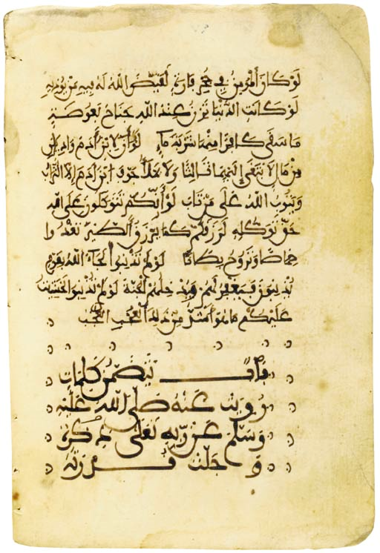
ABU 'ABDALLAH MUHAMMAD IBN SALAMA IBN JA'FAR IBN 'ALI AL-QUDA'I (D. AH 454/1062 AD): KITAB AL-SHIHAB FI AL-AMTHAL WA AL-ADHAB
North Africa or Andalusia, circa 13th Century
Hadith, Arabic manuscript on buff paper, 50ff. with 14ll. of sepia maghribi, titles in large script, copious marginal annotations, f. 39a with colophon signed by the scribe 'Abdallah ibn Maymun ibn Muhammad, light staining and old repairs, composite brown morocco binding with geometric gold tooled decoration, repaired at spine
Folio 7 7/8 x 5¼in. (20 x 14cm.)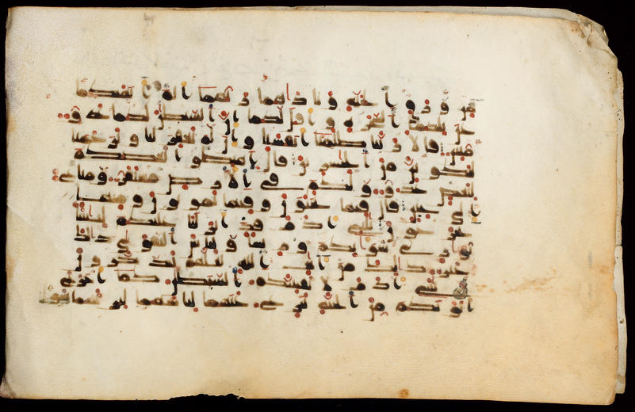
9/10th c Maghribi script Vellum Quran leaves

Bibliography
Brill. Brill Studies in Middle Eastern Literatures, Volume 34 : Looking Back at al-Andalus : The Poetics of Loss and Nostalgia in Medieval Arabic and Hebrew Literature. Boston: Brill Academic Publishers , 2009. eBook.
Ecker, Heather. Caliphs and Kings. Washington DC: Smithsonian Institute, 2004.
JAYYUSI, SALMA KHADRA. THE LEGACY OF MUSLIM SPAIN. NEW YORK: BRILL, 1992.
Jones, Alan. Early Arabic Poetry. Reading: Ithaca Press, 2011.

