Quince Marmalade
(Gisele de la Fontaine)

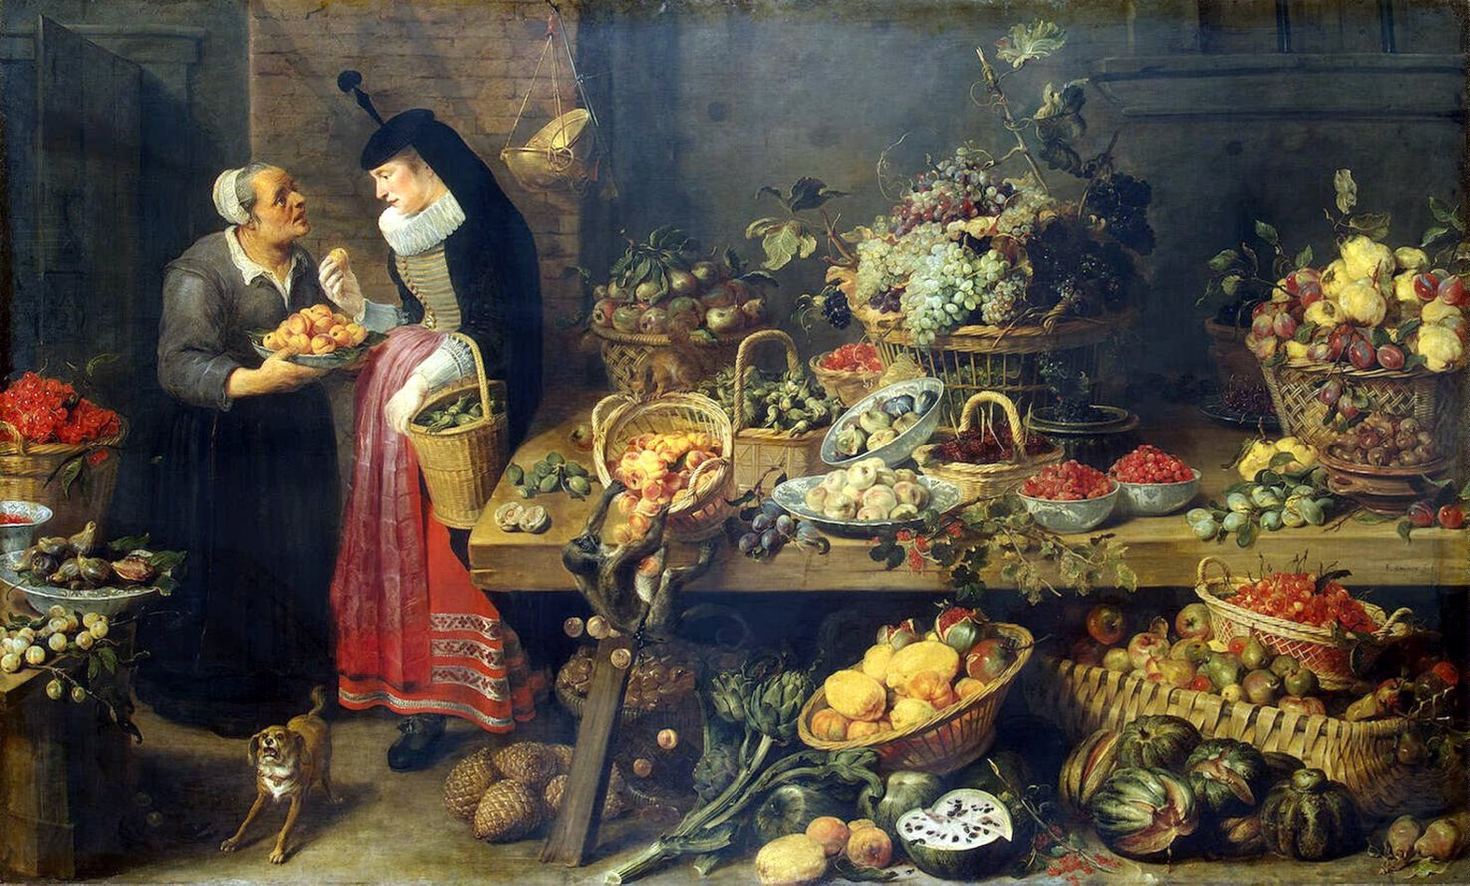
The Fruit Stall, Frans Snyders

Quince Marmalade
Country of Origin:
For this particular preparation, I used an English recipe from Hugh Plat’s Delights for Ladies to adorne their Persons, Tables, Closets, and Distillatories; with Beauties, Banquets, Perfumes, and Waters. Written between 1600 and 1602, it was first published in 1602 and it had several reprints over the 17th century. The quince plants themselves are native to the Middle East and were cultivated widely throughout the region, spreading west though the Mediterranean with the Romans and north from there as trade expanded throughout Europe.
Period of Origin:
This preparation is late Renaissance, but similar recipes exists previous to this in Italy and Spain. This particular recipe was selected because it has very little spice added to it and showcases the quinces’ unique flavor better than a 14th century spiced version from Libro Per Cuoco(Anonimo Veneziano). While the 14th century version is good, having made it once, the spices cloud the floral notes of the quince a bit and I find it much too sweet for my taste, having twice the sugar added to it.
Intended Setting:
A dish served after a feast or large meal, believed to aid digestion and it was recommended to be served after meat courses. The Quince Marmalade was often pressed into moulds that had been brushed with rosewater, to create beautiful, translucent patterns and studded with perfumed ragged comfits to be presented at table(as seen in the included images).
Original text
To Make Marmelade of Quinces or Damsons.
When you have boyled your Quinces or Damsons sufficiently, straine them: then dry the pulp in a pan on the fire; and when you see there is no water in it, but that is beginneth to bee stiffe, then mix two pound sugar with three pound of pulp: this marmelade will bee white marmelade: and if you desire to have it looke with an high colour: put your sugar and your pulp together so soone as your pulp is drawne, and let them both boile together, and so it will looke the colour of ordinary marmelade, like unto a stewed warden; but if you dry your pulp first, it will looke white and take lesse sugar: you shall know when it is thinke enough, by putting a little into a saucer, letting it coole before you boxe it.
Translated/adapted text:
To Make a Marmalade of Quinces or Damsons
When you have boiled your quinces sufficiently, strain them, and dry them in a pan on the fire. When you see there is no water in it, but it is beginning to be stiff, then mix two pound sugar with three pound of pulp. This marmalade will be white marmalade and if you desire it to have high color, put your sugar and your pulp together as soon as your pulp is drawn and boil them together so it looks the color of ordinary marmalade, like a stewed warden. If you dry your pulp first, it will look white and take less sugar. You will know when it is thick enough but putting it into a saucer and letting it cool before you box it.

Ingredients:
6 lbs of Ripe Quince
2 lbs of wildflower honey
2 qts water or enough to cover the quince for boiling

Cooking method:
First take your quince and give them a really good scrub with some water to remove any of the grey fuzz that may still be clinging to the skin. Place whole quince in a 6 qt slow cooker, cover with water and set on high for about 4 hours or until they are very soft. This method provides a consistent heat and a gentle, simmering boil as opposed to hard boil. I find this makes them much easier to handle in later steps, reduces the amount of fruit lost to peeling/coring and allows the skin to perfume the water and fruit.
Once quince are soft, gently remove from the water and allow to cool a bit before coring and straining, reserve the water for later. When quince are still warm but cool enough to handle, split open and scoop out the grainy core and seeds, it should separate easily from the soft fruit. Next strain your fruit to remove the skins and make a smooth pulp, if fruit needs a little more moisture to make straning easier, use a little of the quince water. Return quince pulp to the slow cooker and stir in your honey. Set slow cooker to Low and leave the lid off, we are cooking the pulp down to improve the color and dry it out before “boxing” or spreading out to finish drying. Give the pulp a stir about every hour or so, to ensure even evaporation, for between 5 to 7 hours, or until it becomes quite thick and a becomes a semi opaque, claret red.
Now comes the final drying, which will set it up at a firm jelly texture and enable it to keep for a very long time. Take a very fine tea towel, thin muslin fabric or parchment paper(each have their pluses and minuses for use) and cover a large baking tray making sure there is a bit hanging over all the edges, next spread paste in a even layer over the entire tray, about ½ inch thick. Place in a safe location and after about three days, you will want to check it and turn it. The top should feel tacky, but not sticky and the edges should peel away from the fabric/paper easily. Turn it to ensure even drying, flip entire slab onto a second piece of fabric/paper and allow to continue to dry until fabric/paper peels away easily from entire slab. (You can speed the process up by placing in an over set to the lowest temp possible and placing prepared baking sheet in the oven, rotating/flipping every couple hours until the paper peels away cleanly.)
Once slab is dried to tacky but not sticky and peeled away from the fabric/paper it may be sliced and stored. To store, layer in a container with bay leaves for a more period approach or parchment paper if you don’t want to use a million bay leaves. This will keep for well over a year, but it is unlikely to stick around that long.

Research and References:
Plut, Hugh, Sir, Delights for Ladies to Adorn their Person, Tables, Closets, and Distillatories, with Beauties, Banquets, Perfumes and Waters.
Library of Congress Digital Archives http://hdl.loc.gov/loc.rbc/Pennell.17891 originally printed in 1600, reprinted in 1644, London. Pg. 55 of scanned archival document, recipe number 31.

Santich, Barbara, The Original Mediterranean Cuisine Medieval Recipes for Today.
Book,Chicago Review Press 1995 Kent Town, South Australia

Anonymous Version (Anonimo Veneziano) Libro di Cucina/Libro per Cuoco(14th-15th century)
Translated by Helewyes de Birkenstad, OL(MKA Louise Smithson) from the transcription of Ludovico Frati (ed.): Libro di cucina del secolo XIL. Livorno 1899, prepared and available online by Thomas Gloning. Online text: http://helewyse.medievalcookery.com/libro.html#CXXXIII

Day, Ivan, “Quince Recipes” HistoricFood.com 2005 http://www.historicfood.com/Quinces%20Recipe.htm

Visuals

Frans Franke II
Lazarus and Dives (1603)
Close up of Quiddany of Quince

Frans Francken the Elder,
The Feast of Harrod 1542.

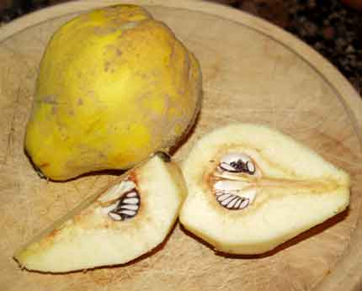

Raw Quince Photo
You can see the grey fuzz and the large number of seeds.

